* **Retrieve all records from CHALLAN_HEADER**

SELECT * FROM CHALLAN_HEADER;

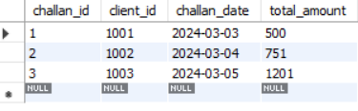

* **Retrieve all records from CHALLAN_DETAILS**

SELECT *FROM CHALLAN_DETAILS;

